Russian Revolution: There’s nothing to celebrate about the 100th anniversary of Communism

Historian John Lewis-Stempel says there’s nothing to celebrate about the 100th anniversary of the arrival of Communism, which simply replaced an autocratic sovereign with totalitarian dictators.
PUBLISHED: 07:01, Sun, Oct 29, 2017 | UPDATED: 09:17, Sun, Oct 29, 2017
https://www.express.co.uk/comment/expresscomment/872638/Russian-Revolution-100-years-communism
*Edited for length.
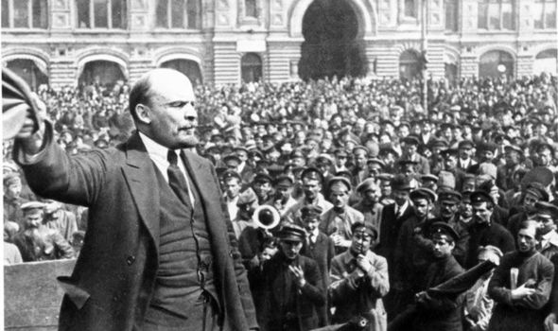.
There is nothing to celebrate. The year 1917 actually saw two revolutions in Russia. The February Revolution (in March, according to the modern calendar) deposed Tsar Nicholas II after more than 300 years of rule by the Romanov dynasty, ushering in a provisional government that implemented progressive reforms such as universal suffrage.
In truth, the Bolsheviks exploited the fears of the workers, the poor and the peasantry for their own ideological ends. Famously, according to Marx’s theory of dialectical materialism, all history is “the history of class struggle” with the end result being the seizing of power by the “proletariat”, the workers, via revolution.
Lenin's addition to Marxism was to claim that a “vanguard” was required to lead the workers into the new dawn. Happily for Lenin, the necessary vanguard was his entirely self-appointed Bolshevik party.
The Bolsheviks, previously aimless, became ardent and directed towards power. One observer likened the audience to “bewitched disciples”. On the night of November 6 the Bolsheviks launched their coup.
If the actual coup was carried out by just a few hundred, hundreds of thousands of workers and soldiers anticipated a new and improved existence for themselves under Communism.
Such high hopes, so quickly and utterly disappointed. Once in power, the Bolsheviks abolished private ownership of land. Free and fair elections were promised.
When the Bolsheviks lost the elections with a paltry 24 per cent of the vote (and that was rigged), Lenin ordered the Red Guard – the party’s private army – to shut down the elected assembly.
Instead, he installed himself as dictator. Russia descended into civil war, eventually won by the “Red” Bolsheviks over their “White” opponents. The White Russians’ usual fate if captured was to be shot against the wall or, when the bullets ran low, hanged.
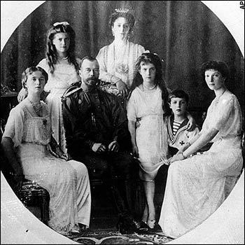
Everything material was in short supply in the brave new world of Communism. Except blood, which was the motif of the Revolution. In July 1918 the royal family, including the five children, were shot, bludgeoned and bayoneted to death in the basement of a building in Yekaterinburg.
This Photo by Unknown Author is licensed under CC BY-NC-ND
Their corpses were mutilated before burning, doused in acid and dumped in a pit in the forest. The order for the deaths of the Romanovs came directly from Lenin, hand-delivered by his chauffeur.
Eventually, the Bolsheviks turned on their own. The sailors of the Kronstadt naval base, previously staunch advocates of revolution, asked for modest reforms, among them freedom of speech for all workers’ parties and the release of socialist political prisoners.
Lenin smeared the sailors as “Black Hundreds”, nationalist paramilitaries, and sent in his Red Guards. Thousands of sailors were killed or imprisoned. Kronstadt was incontrovertible proof that Bolsheviks ruled only for themselves.
Lenin had no real sympathy for the poor, or for them bettering their lot. Absolute power was his aim. Violence was his means. The Communist plan to boost the country’s ramshackle economy flunked.By 1921, the year of the Kronstadt protests, the output of mines and factories was 20 per cent of the pre-Great War level. To prevent more protests Lenin introduced a New Economic Policy permitting kulaks, peasant farmers, to sell their surplus crop for profit.
But when his successor, Stalin, subjected them to enforced collectivisation in the 1930s, two million kulaks died of starvation or brutality. Stalin opined: “A single death is a tragedy; a million deaths is a statistic.”
To consolidate his power, Stalin duplicated the state-terror practices of his predecessor: exile in Siberian forced-labour camps, torture, mass murder, execution, show trials of allegedly unfaithful party members. Russia rattled to the midnight knock on the door by the NKVD, the secret police.
The blood flowed and flowed. During 1932 and 1933, Stalin directed the Holodomor in Soviet Ukraine, a deliberate mass famine – intended to halt Ukrainian independence – that killed another four million Russian citizens.
The Black Book of Communism, edited by the French academic historian Stéphane Courtois, catalogues the number of people killed by the Communist dictatorship in Russia before its eventual fall, in 1991, as 20 million.
Every Marxist state since has likewise been an exercise in tyranny and terror, whether Mao’s China, Castro’s Cuba, Pol Pot’s Cambodia or Kim Il-Sung’s North Korea.
Worldwide, Communism has been responsible for the deaths of 96 million people. All the November Revolution brought the Russian people was a change of authoritarian regime.
They swapped the Romanovs for the Red Tsars of Communism. All 1917 brought the world was oppression, blood and tragedy.

